# ELECTRONIC SHIPPING - RECEIVING CONFIRMATION SYSTEM

## - Software requirements

-MFGPRO Data Download Service updated to version 1.0.8, to download shipping and receiving data and mailing.

- Stocks Control updated to version 1.0.20, for mailing settings and customer-responsible, supplier-responsible relation settings.

- Electronic shipping-receiving software installed on intermec tracker.

## – Settings

We have to access stock control to set up the parameters we need to run properly the Electronic Shipping-Receiving software.

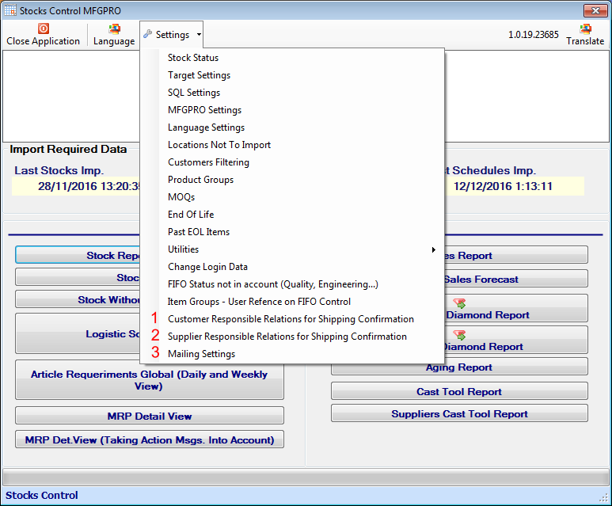

### [1] – Set up Customer-Responsible relations

Select the customer and add the responsible people who have to receive the mailing report confirmation mail. You can modify mail if it’s wrong on your database.

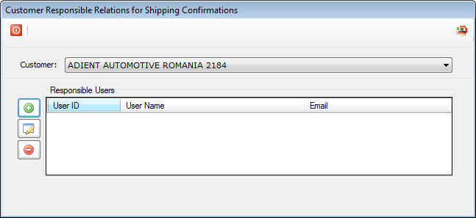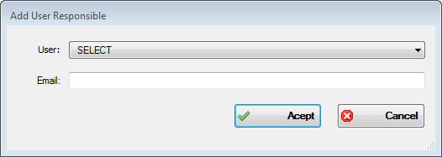

### [2] – Set up Supplier-Responsible relations

Select the supplier and add the responsible people who have to receive the mailing report confirmation mail. You can modify mail if it’s wrong on your database.

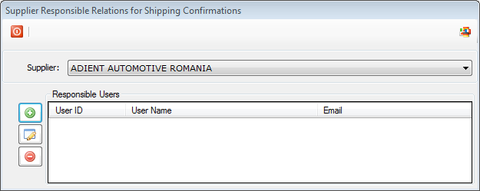

### [3] – Mailing settings

Set up the mail account to send the mails with the shipping – receiving reports to the responsible people.

### 

## 3. - ELECTRONIC SHIPPING-RECEIVING SOFTWARE

3.1 Login into application

To use the electronic shipping-receiving software functions user has to log in with the Adient global ID, and accept, if press cancel buttons are disabled.

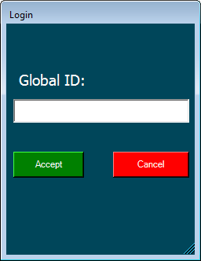

### 3.2 Main menu

Shipping: Access to the shipping validation function.

Receiving: Access to the receiving validation function.

Login: Access to the login screen, if you cancel the initial login or to change the user which is using application.

Exit: Exit program.

At the bottom we have the user name logged on the software.

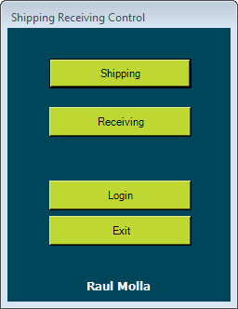

### 3.2 SHIPPING CHECKING FUNCTION

Write the shipper number to check and accept to download data.

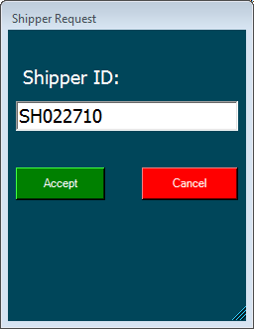

In case you’ve downloaded previously this Shipper ID you’re asked for download again. Press yes if you want to refresh information (lot serial changed by logistic department or another change done), or press no if you want to continue with the downloaded data.

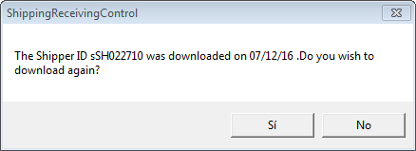

While data is being downloaded the shipper validation screen remains in this state [Requesting].

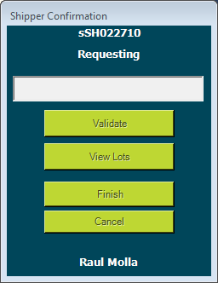

When status change to [Downloaded] you can start with the validation process.

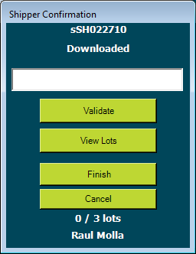

You have to scan the lot serial barcode (if scanner is configured to do enter after barcode scan lot validation is done automatically, if not you have to press Validate button to do it).

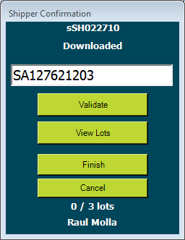

At the bottom of the screen you have the status of validation (validated lots / shipper lots).

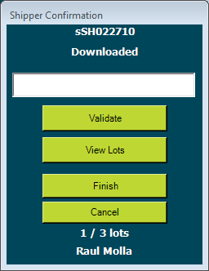

If you have doubts of which lots are validated or not, pressing the view lots button you can see in red which lots are validated (Green) and which aren’t (Red).

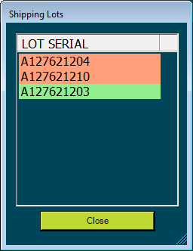

If you press Cancel button on validation screen you’re asked for cancel the validation process. For example if you find an error on lots assignation, you have to cancel and talk with logistic department to check it.

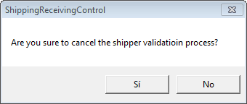

If you press the Finish button and you don’t have validated all lots you’ll be warned about it and returned to the validation screen.

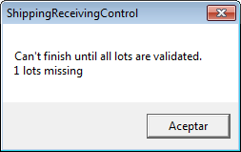

If you’ve validated all lots the validation screen will be closed and mail to the responsible people will be sent automatically.

Sample of mail:

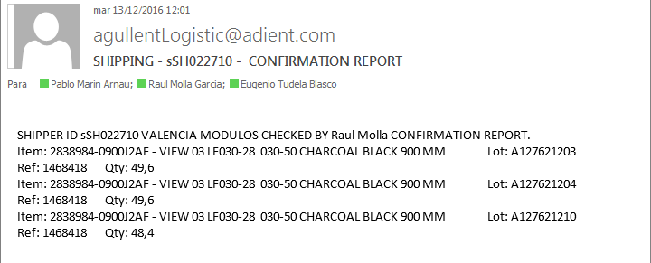

### 3.3 RECEPTION CHECKING FUNCTION

Write the delivery note number to check and accept to download data. The delivery note must be entered on MFGPRO previously to this process.

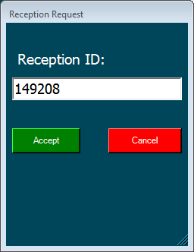

In case you’ve downloaded previously this Reception ID you’re asked for download again. Press yes if you want to refresh information (lot serial changed by logistic department or another change done), or press no if you want to continue with the downloaded data.

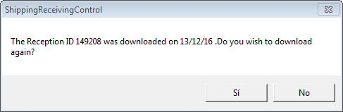

While data is being downloaded the reception validation screen remains in this state [Requesting].

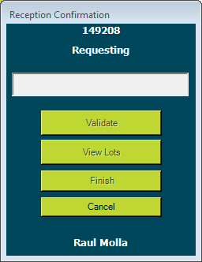

When status change to [Downloaded] you can start with the validation process.

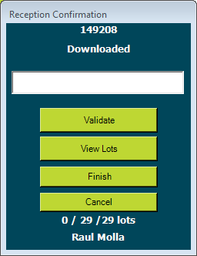

You have to scan the lot serial barcode (if scanner is configured to do enter after barcode scan lot validation is done automatically, if not you have to press Validate button to do it).

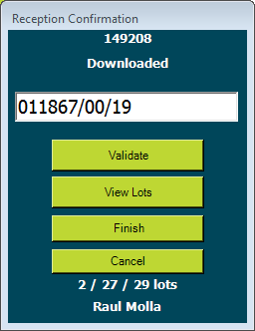

At the bottom of the screen you have the status of validation (validated lots / remaining / total lots).

If you have doubts of which lots are validated or not, pressing the view lots button you can see in red which lots are validated (Green) and which aren’t (Red).

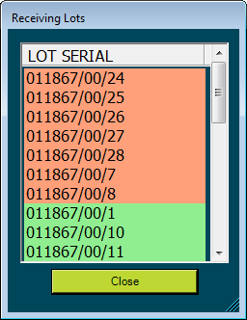

If you have a lot serial which isn’t on delivery note document introduced on MFGPRO you’re asked for add it to the reception. This will be on ‘Added’ status, and reception will be marked as NOT OK. If you’re reading a wrong lot or wrong code, press cancel to skip adding this lot.

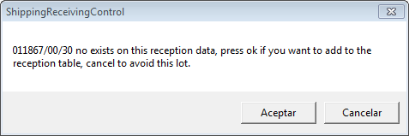

If you press Cancel button on validation screen you’re asked for cancel the validation process.

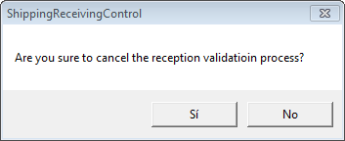

When you press finish in the reception validation process, resume of reception result is shown, you can see how many lots are ok, missing or added, if you agree with the information press Yes, if not press No to read missing lots or cancel and start again the validation process.

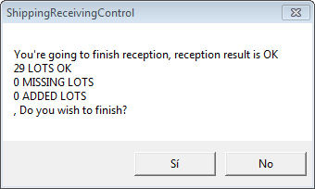

When you press yes to this confirmation a mail with the reception confirmation report is sent to the responsible people assigned to the supplier.

